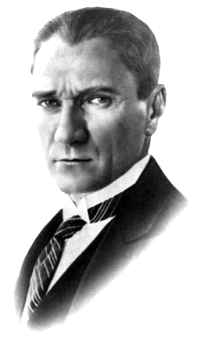

MUSTAFA KEMAL ATATÜRK
1881-1938

